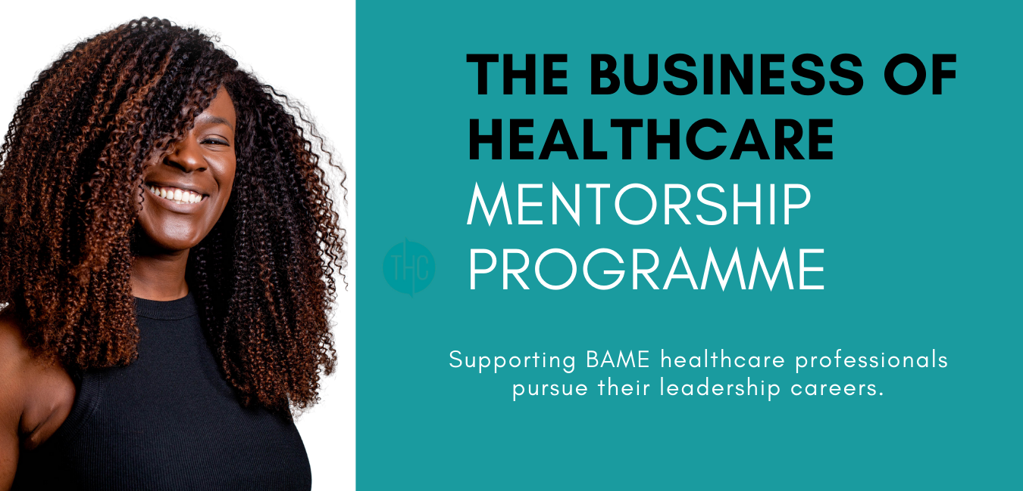
Mentorship Application Form
Thank you for applying for the Business of Healthcare Scholarship.
Please complete the application form below and send your completed application form and additional supporting items to sophie@thcprimarycare.co.uk

The deadline for all applications is by 4pm on Wednesday 31st August 2022
We will aim to notify candidates of the outcome by Wednesday 16th September
If you have any questions, then please feel free to email sophie@thcprimarycare.co.uk or call Chantelle on 07494768533.

Good luck!
From Team THC
By submitting this scholarship application form, you agree to receive updates and marketing from THC Primary Care. You will be able to unsubscribe from these at any time by clicking the unsubscribe link in the footer of any email you receive from us.
We will treat your information with respect. For more information about our privacy practices, please visit our website. By submitting this application, you agree that we may process your information in accordance with these terms.

Application Form
Name
Email
Phone number
Home address
Current workplace
Organisation address
Ethnic Origin
200 word personal /professional reference contact details
Reference contact details
(Email, phone number and relationship)
200-word summary:  Why would you like to be considered for the Business of Healthcare Mentorship Programme? | (200 words max)

Supporting items – please tick the box to confirm you have sent us the following:
CV (Please provide in Word or PDF format)
Two-minute Video - Introducing yourself and why you would like to be considered for the Business of Healthcare Mentorship Programme
(Please provide in MP4 format. If too large to send via email, please send via WeTransfer and note on your application form you have sent a WeTransfer link.)
Evidence that you have listened to one episode of The Business of Healthcare Podcast.

